

When you first arrive, you will need to let the staff know you’re here.

You will see lots of staff in this department. There may be nurses, healthcare assistants, doctors, phlebotomists, reception staff and health play staff.

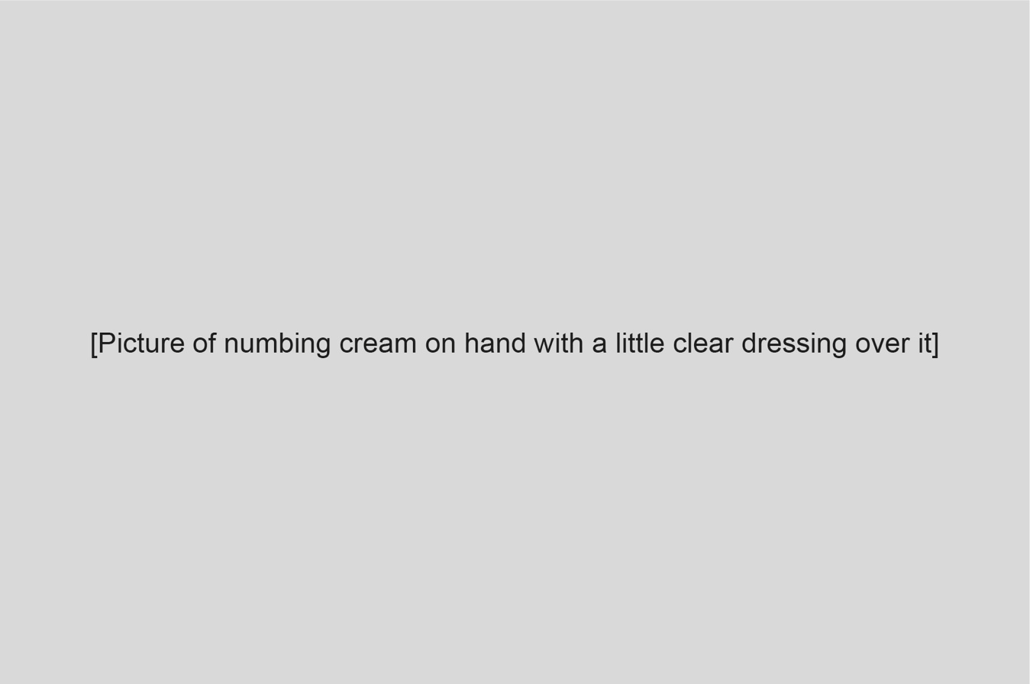
Before you have your blood test, you may be able to have some numbing cream on your hand or arm. This helps your skin feel less sensitive and needs to stay on for 30-40 minutes to work properly.
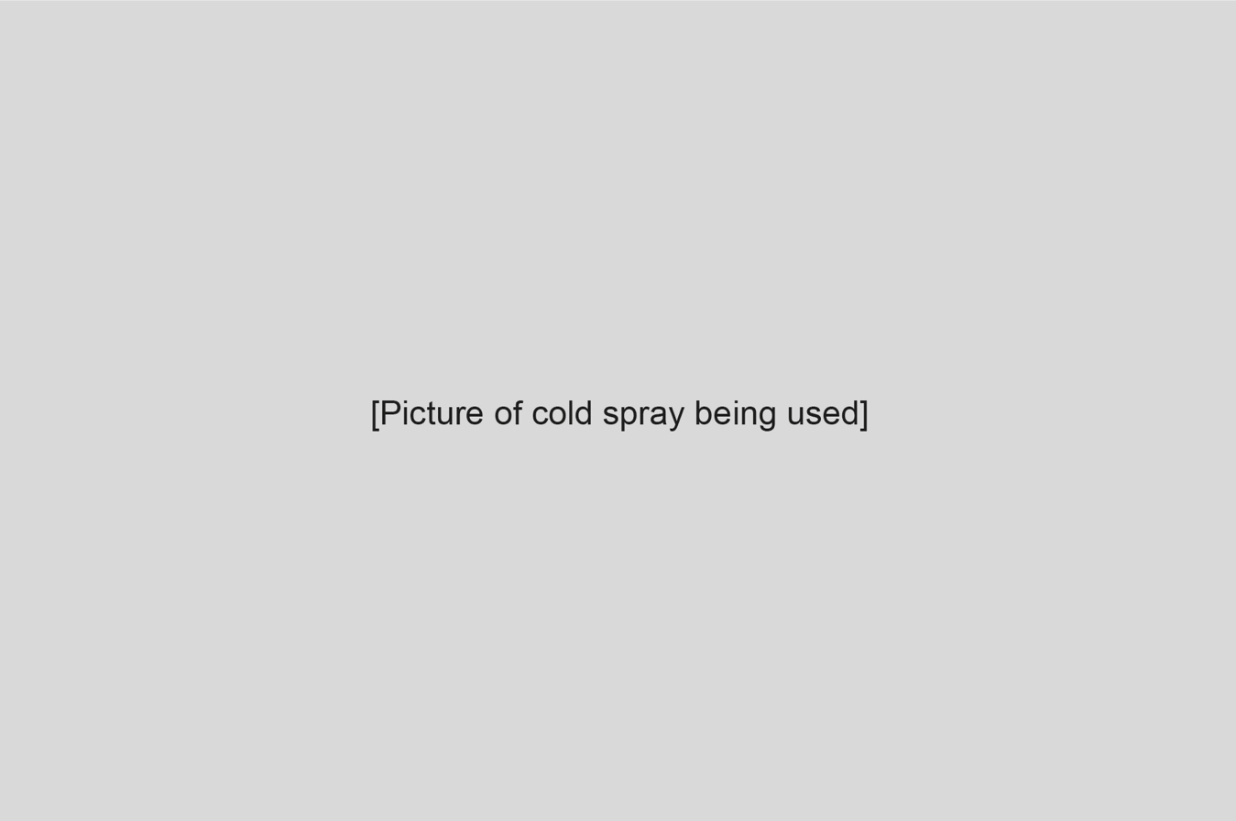
Sometimes, you might have a cold spray to help your skin feel less instead. This works straight away and will be used just before the blood test.
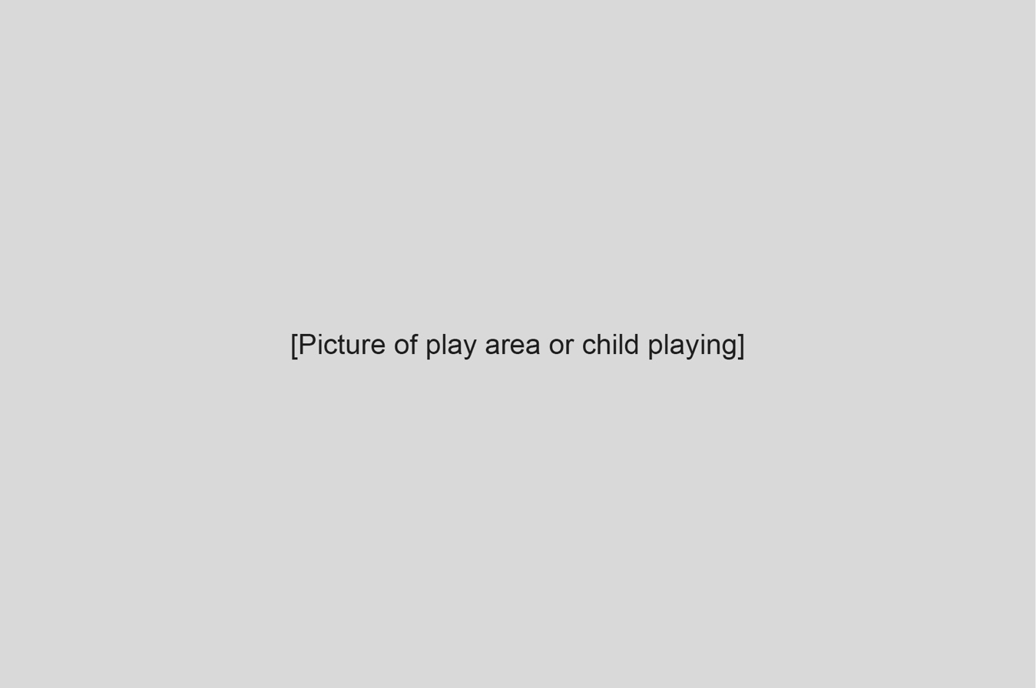
While you’re waiting, you can play! The play staff may bring toys, books or games.


When it’s your turn, you’ll be called to the blood test room.

You will meet someone called a phlebotomist. They will help you with your blood test.
You’ll sit on a chair or bed.

You might be able to sit on your own, or on your grown-up’s lap. Have a think about how you would feel most comfortable and what would make it easier to sit super still.


You can look at a toy or book while the test happens, if you choose to.


The phlebotomist will check your hand or arm again to find the best vein.


When the phlebotomist finds a good vein, they will put a stretchy band called a tourniquet around your arm. This gives your arm a gentle squeeze and helps the vein stay easy to see.

If you are having cold spray instead of numbing cream, you will have this now. It will be sprayed onto your skin where your vein is.
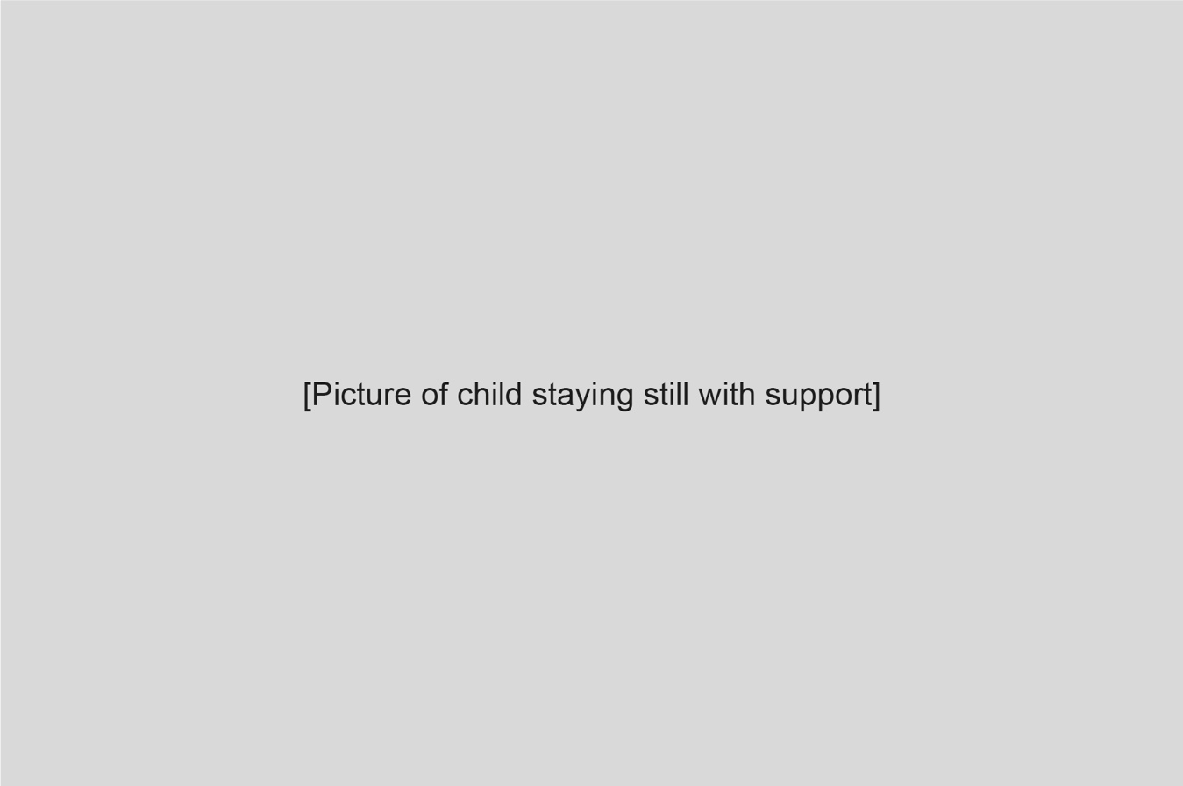
Now it’s time to sit very still like a statue while the blood is taken.
All done! You did it!
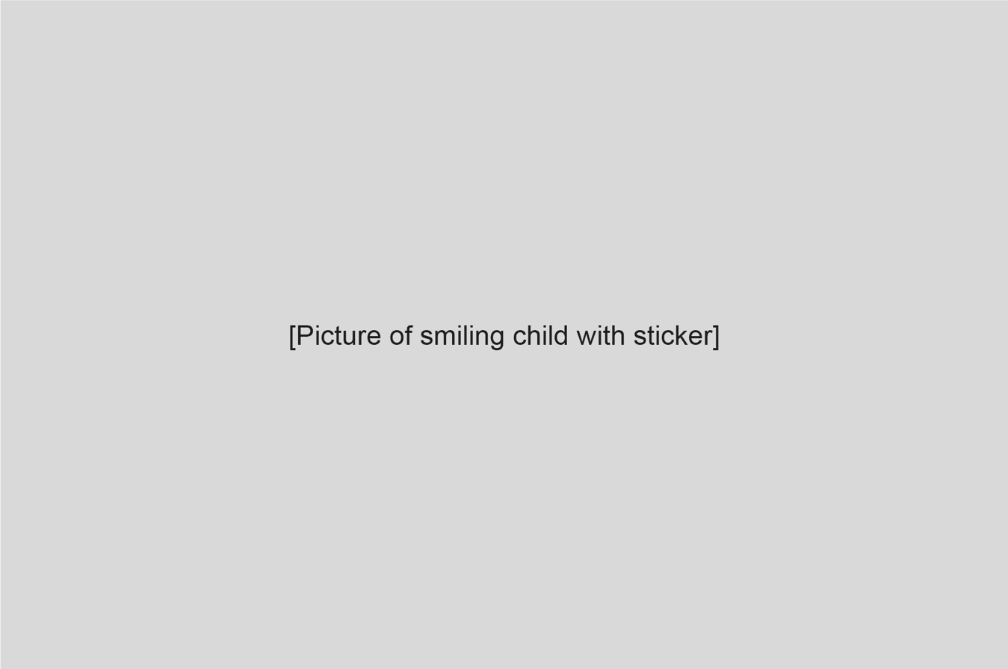
Now you can choose a sticker for being so brave.

Time to go home. Your test will be sent to the lab now, to help the doctor find out what is happening inside your body.
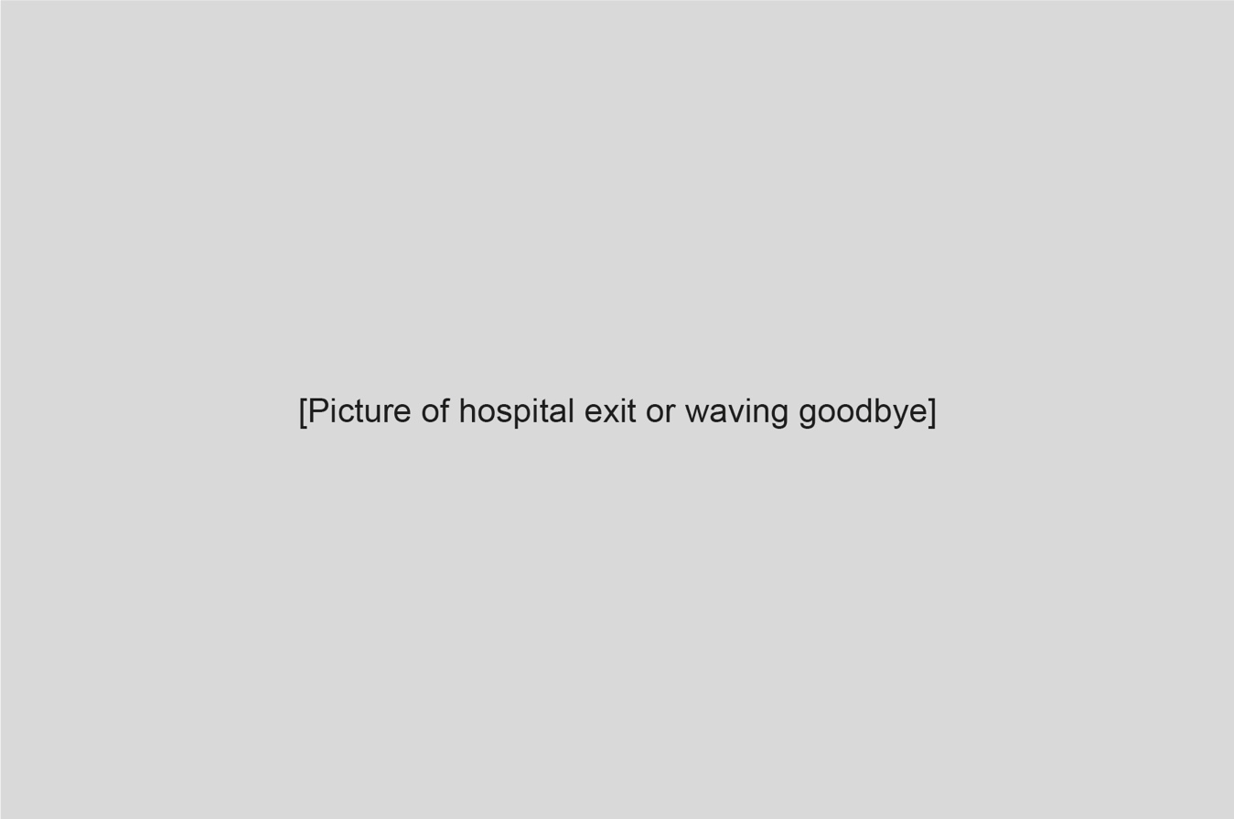
Well done for doing so well.


Optional pages to add
- What is blood and how do we test it? (A simple sentence or two explaining it).

- Feelings Page: “It’s okay to feel nervous, curious or brave.” (Add faces showing different emotions, and a space to draw how they feel).

- Top Tips for Grown-Ups: Short section with practical tips for parents, like helping their child stay calm, bringing distractions and what to expect.

