

There are many different ways you and your grown up can travel to hospital. This may be in your car, by bus or train, walking, or even with help from an ambulance.

When you arrive at the hospital you will need to find the ward/department you will be visiting. There will be signs to help you.


Sometimes you may need to go in a lift or on some escalators to get to the place you need.

You may see lots of people in the hospital. Many will be there to see doctors and nurses as well. Some may work at the hospital.


You will hear lots of sounds in the hospital too. These may be from coffee shops, restaurants, people talking or recorded messages playing to help people.

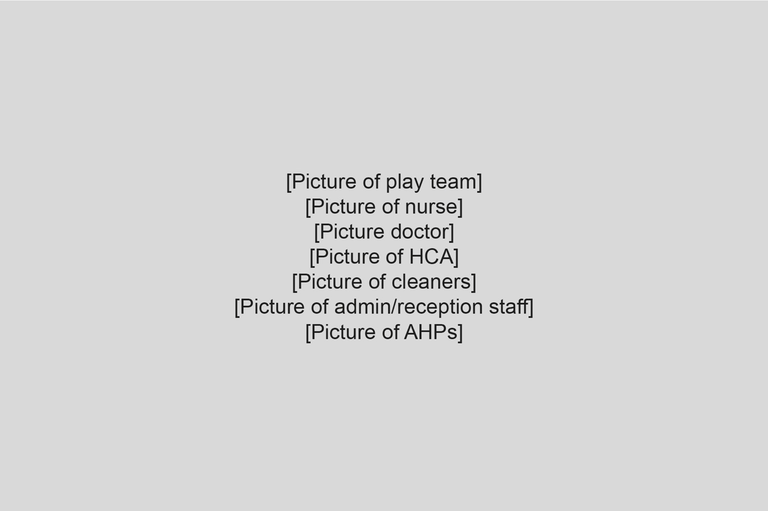
There are many people that work within a hospital. They all have very important jobs to help keep the hospital safe and clean and to help to look after you. They all wear different clothes that help you to know which job each person has.


Lots of areas in the hospital will have toys for you to play with and things for you to do to make it fun. You can also bring some special toys and things to play with from home.

While at the hospital, you may visit an outpatients department or the emergency department. You are usually only here for a short amount of time.


Sometimes you can have scans and tests at the hospital. A play specialist will be able to help you to understand these and answer any questions you have. They may have a special book or toy to help to explain these to you.
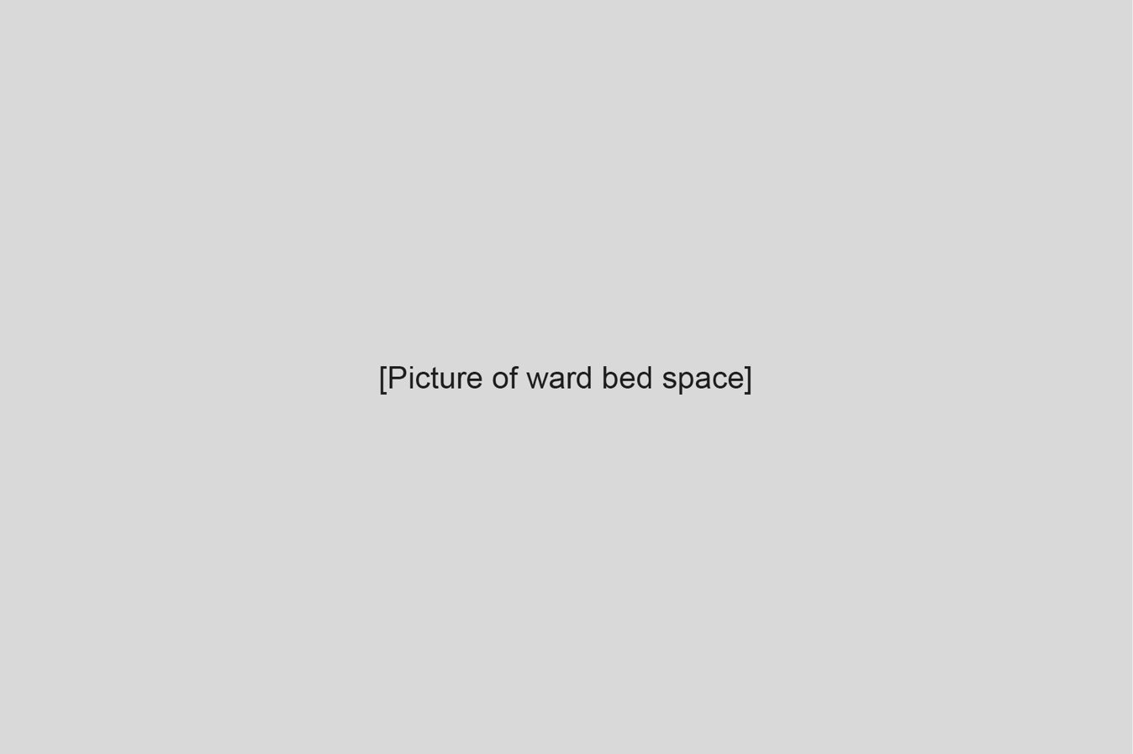
You may also visit a ward, where you can sometimes sleep overnight. You will be able to have a grown up with you overnight and you will each have your own bed.


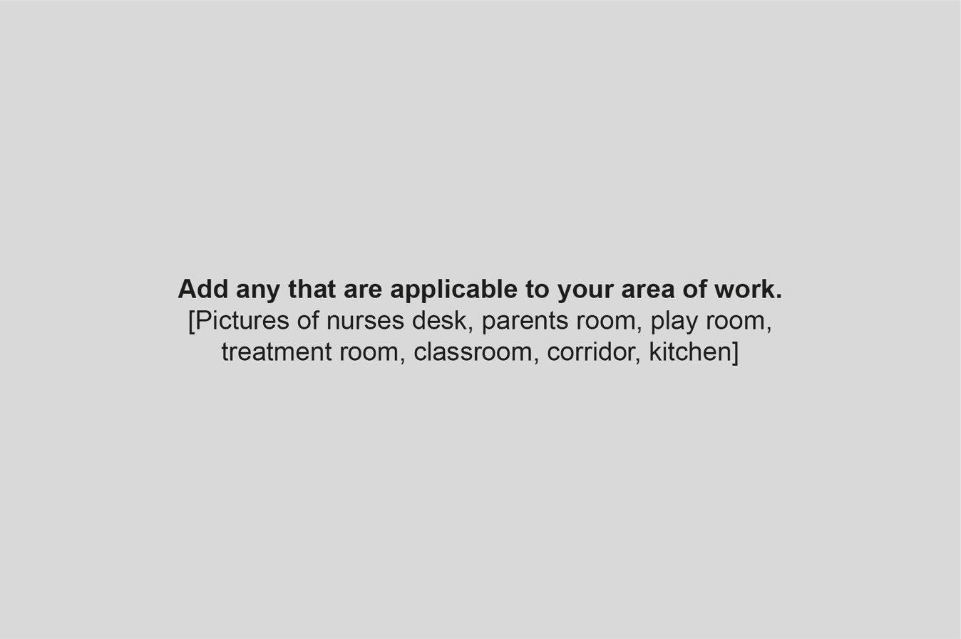
Lets have a tour of the ward/department and see if you can find all these areas.

