When you arrive at the hospital, you’ll need to let the staff know that you’re here.

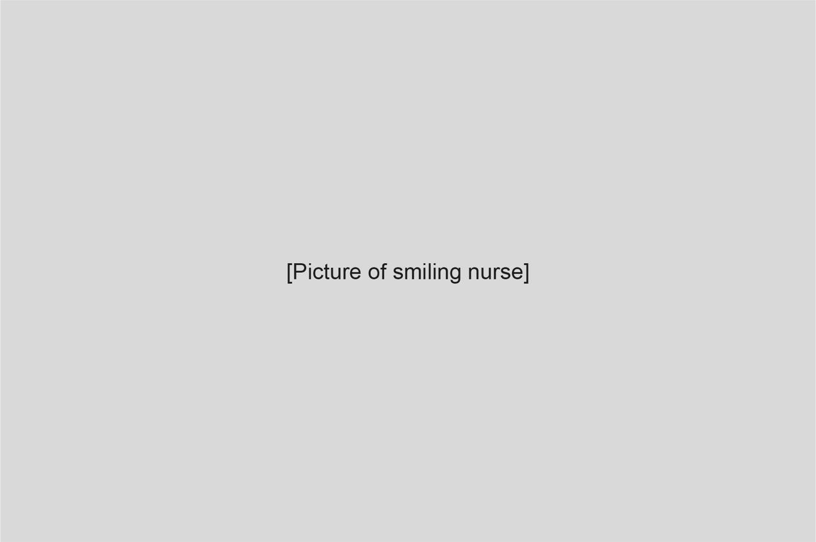Next, you’ll meet a nurse.

Before your surgery, your nurse will do some observations. These are simple checks to see how your body is working.

* First, your weight will be measured. You can sit or stand on the scales.
* Next, your temperature will be taken, either under your arm or under your tongue.
* 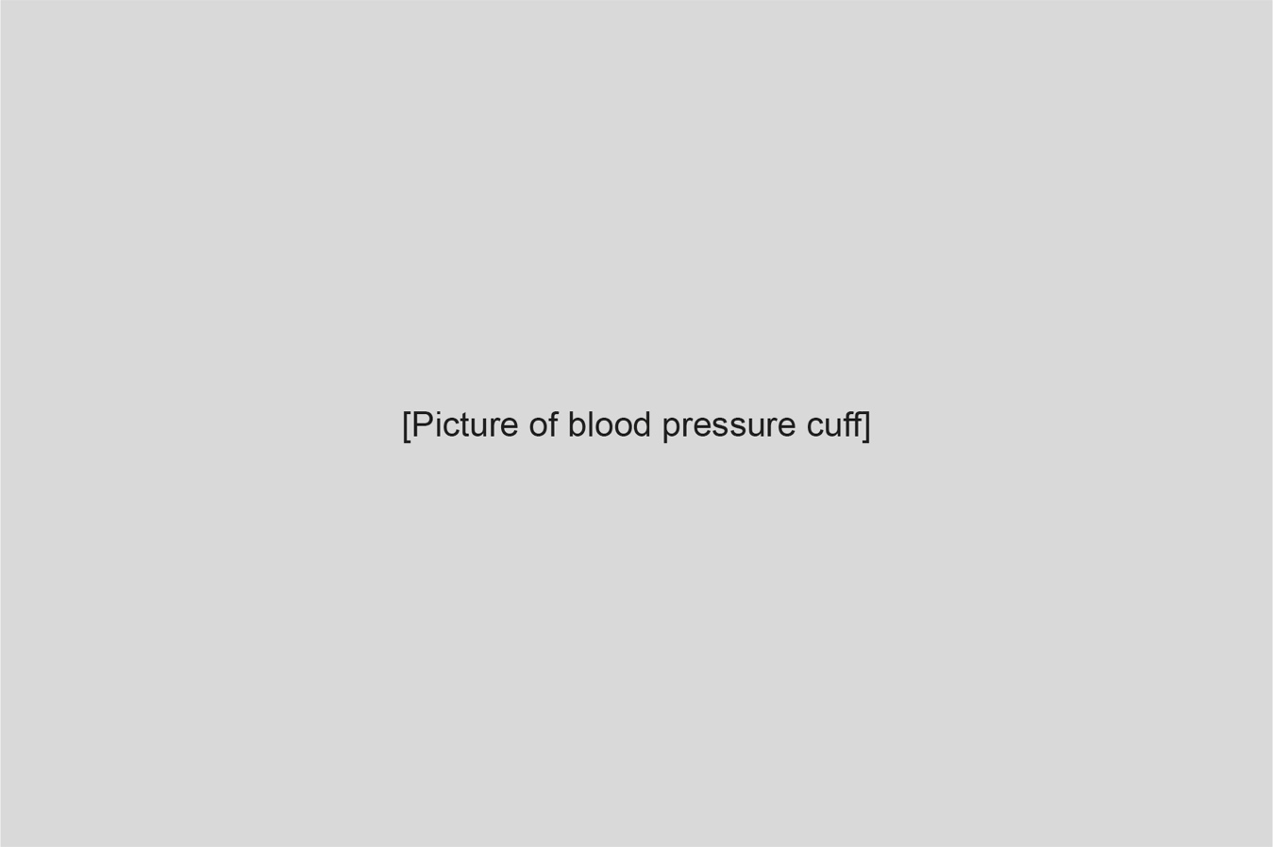Your blood pressure will be checked with a soft cuff that goes around your arm. It gives your arm a gentle squeeze, then beeps and shows some numbers.

You may have numbing cream put on your hand or arm. This helps your skin feel less. It takes about 30 – 40 minutes to work.

You’ll be given a name band to wear on your wrist. This tells the doctors and nurses your name, birthday and hospital number.

You’ll meet lots of friendly people while you’re at the hospital. They are all here to help you!

You might meet:

* Doctors
* 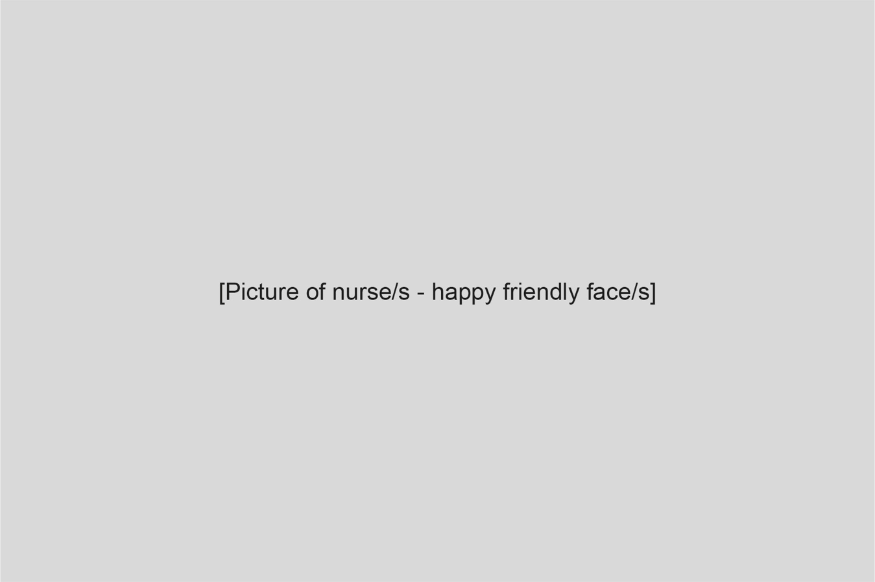Nurses
* Anaesthetists (they help you go to sleep for your operation)
* 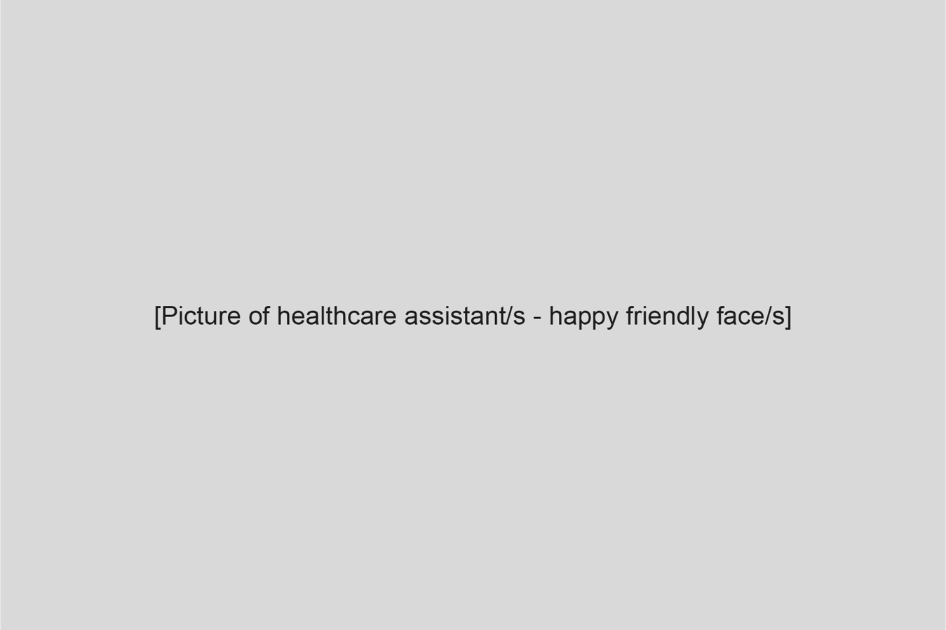Healthcare assistants
* Play specialists (they bring toys and help you feel calm)A screenshot of a computer

  AI-generated content may be incorrect.

After you and your grown-up have talked with the doctor and anaesthetist, you’ll be asked to change into a hospital gown.

While you wait, you can play, read a book, or watch something on TV. The play specialist can bring toys to you, or you might be able to visit the playroom.

You won’t be able to eat or drink while you wait – this is because your tummy needs to be empty before you have your sleepy medicine.

When it’s time for your operation, you’ll go to the anaesthetic room with your grown-up and a nurse. You might walk, or you could go in a wheelchair or on a bed with wheels.

In the anaesthetic room, there will be a nurse, two anaesthetists, your grown-up and maybe a play specialist too.

You will be asked to lie down on a bed. The anaesthetist will ask you and your grown-up a few questions.

There are toys and books in the room, and you can also bring a soft toy from home.

There are two ways to get your sleepy medicine:

1. A white background with black text

   AI-generated content may be incorrect.Using a bendy straw called a cannula – a little tube goes into a blue vein in your hand or arm where you had your cream or spray. A white, milky-looking medicine goes in and helps you fall asleep.

If you didn’t have numbing cream earlier, you may now have a very cold spray on your skin. This works quickly to numb your skin and is used just before your cannula.

1. A white background with black text

   AI-generated content may be incorrect.Using a mask – this soft mask goes over your nose and mouth. It has a balloon on it. You take big, deep breaths to blow up the balloon. The sleepy medicine is inside the mask.

While you’re asleep, the doctors will do your operation.

You might dream, or it may feel like you’ve only just gone to sleep when it’s time to wake up again.

When you wake up, you’ll be in the recovery room. The nurse will call your grown-up to come and be with you.

Then you’ll go back to your bed on the ward.

temperature and blood pressure.

When you wake up from your sleep, you will still have the cannula in your hand or arm. It may be under a bandage. Sometimes the nurse may need to use the cannula to give you medicine or fluid after you wake up, so it will stay in place until you are feeling ready to go home.

something to eat.

When you’re feeling better, it will be time to go home!

